Playing the Game
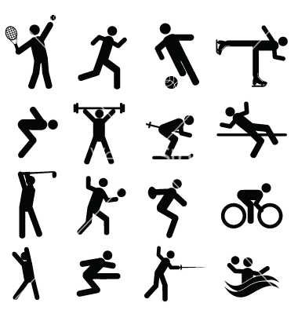

English Studies
Stage 6 English

Module description
Through the study of the module Playing the Game – English in Sport students will develop understanding of and practical competence in the language used in recreational and professional sport at a local, national and international level. Students explore how language is used by a range of people such as coaches, players, journalists, sports writers, and makers of films and documentaries. Students consider how language is used in sport to enthuse and motivate, report and analyse team and individual performances, create and sustain interest in sporting stories and issues, and persuade the public and individuals to particular points of view. This may involve writing personal recounts about sporting experiences or writing about the experiences of others involved in sport in relation to fitness, motivation, success, failure and enjoyment.

Students will also have the opportunity to experience, engage with and critique literary texts that illustrate, through an imaginative use of language, how sport can spark enduring stories about important issues, legendary feats, ambition, success and failure, relationships, controversy, motivation and fitness. Texts may include longer works such as novels, biographies, autobiographies, plays and films. Through the study of a range of literary texts in both written and electronic forms, students will broaden their understanding of the importance of language in the presentation and promotion of sport to the wider community, and how individual and collective commitment to sport as a profession or as recreation is created and sustained. In addition, by engaging with these texts, students will extend their own skills in comprehending and responding to texts, and their own abilities to use language expressively and imaginatively.

Focus 1: Can sport shape your identity?
Student Quiz:

- What is Michael Clarke known for?
- What is Tiger Woods known for?
- What is Cathy Freeman known for?
- What is Ian Thorpe known for?
- What is Don Bradman known for?
- What is Roger Federer Known for?
- What is Cadel Evans known for?
- What is Mark Webber known for?
- What is Muhammad Ali known for?
- What is Michael Jordan known for?

Bonus Question: What is the common link between all of these people? Students should suggest they are known for their sporting achievements, and this would be a good opportunity to suggest that all these people are brothers, fathers, uncles, sisters etc. who do things outside of sport, but it seems their identity is linked to what they do, rather than who they are. Any ideas why?

Teacher explains that the unit students will be studying will revolve around sport, and issues in sport and that a particular focus on language will be carried out. Teacher may draw on the syllabus points below:

Students consider how language is used in sport to
- Enthuse and motivate.
- Report and analyse team and individual performances.
- Create and sustain interest in sporting stories and issues.
- Persuade the public and individuals to particular points of view.

Resource:  Sport and Australia’s National Identity, Latrobe University, 2008.  Students read through article with teacher and discuss its main points. Following the reading students to complete the following questions:  - What kind of qualities do sports teams and sports people have associated with them?  - What links does the author make between televised sport and fictional drama?  - Why is televised sport considered a ‘nation-building event’? What does the term, ‘collective consciousness’ mean?  - Why does the author include references at the end of the text?  Follow Up  - What kinds of words and phrases do sports commentators often use to discuss and describe the achievements of Australians? | H1.1, H1.2
Task 1: Kath and Kim Analysis  Season 1,Episode 3: Sport  Analysis of Language used in the text, and the function of language in sport – for each of the following, write down what was said in the text.  - War Cry  - Coach’s Harangue (or aggressive motivational speech)  - Game Strategy  - Game Terminology (metalanguage)  Further:  - Give examples of deliberate misuse of Australian English, and the inclusion of slang in the text.  - How do these words create humour?  - How does the usage of slang in our community contribute to our national identity?  Character:  Sharon Strzelecki  - Does the character of Sharon find her identity in sport? Offer two examples.  - Does the audience question her identity marker? Justify your response.  Class Discussion:  What happens when Sharon no longer associates herself with sport? What will happen to her long-held identity? What might be the repercussions on her self-esteem or self-image?  What are the dangers to sports people who are only known as a sports figure? What are their options once they’ve finished their career?  To conclude the discussion, class will read: ‘Grant Hackett, Ian Thorpe go from hero to zero while golden girls thrive’ The Courier Mail, Greg Stolz, March 1 2014.  - Prior to reading the article, teacher might ascertain who knows who the two men are, as a way of proving a point that they have become a ‘zero’.  - Deconstruct the title of the article, consider the connotations of the words, how might the language differ from an article about an athlete who was still competing and winning? | H1.1, H1.2, H1.3  H3.1
Task 2: A Post-Cup Tale  Herald, 2 November 1927.  Lament: a complaint, or an expression of grief or sorrow.  - In two sentences, write a summary of what you believe the poem to be about.  - Why does the speaker repeat the line, ‘I ‘ad the money in me ‘and!’?  - What kind of image of the speaker does this text evoke? What language features lead you to this conclusion? The below chart may assist:  Technique Example Effect  Not pronouncing words fully or mispronunciation.  Missing the letter h  Slang  Repetition  Misspellings  Follow up:  Stereotype: an oversimplified representation of a person based on character traits. Eg jock, blonde, nerd  - Does this poem depict a familiar Australian stereotype? (either in full, or in part)  - How ‘Australian’ is it to lament the what ifs… or blame someone for your loss? (whinge)  - 90 years on, does this text still resonate with a modern audience? Why or why not? | H1.1, H1.2, H1.3
Weekly Class Debate:  Sport is a good marker of identity.  Students write up dot points to support both sides of the debate in their workbooks. Students to complete their notes individually before taking a side to support.  Following the debate, students will write a personal response arguing whether sport is a good marker of identity. Students will support their point of view with at least two reasons.  Teacher to model activity on board, and if necessary, brain storm some ideas with the class. | H2.1, H2.2, H2.3  H3.1, H3.2  H4.1, H4.2

Joseph Platt
Sport and Australia's National Identity
25 Sep 2008

Around the world sports have developed into popular forms of entertainment that have attracted masses of citizens from many countries. As a result of this the portrayal of sport through the media has helped nations develop their own identities. Australia has long had a strong connection with sporting culture and this has allowed governments to create various representations about Australia’s culture and its people. Looking at various sports and sporting events, such as the 2000 Sydney Olympic Games and the popular football codes, as well as their exposure on Australian television it can be seen that the national identity of the country is projected in specific ways. The identity, of a nation and its citizens, can be influenced by the way the media is able to represent various images through sport.

Governments have long used sports and sporting events as a way to promote their ideas of their nation’s identity. Author Joseph Maguire writes… “sport and national identities have been intertwined”. In turn the media has become the most important way to get the messages of our culture across to the public and world community and as a result “most sporting cultures are to some extent mediated through television, radio or the print media”. [It is believed] that governments are able to use ideas from sporting culture to construct identities by producing symbolic meanings about the country in which the citizens are able to identify with. Australia’s sporting teams are always promoted in the media as having certain nationalistic qualities and identities, which we are able to recognise. This shows, according to Martin Polley, that a national team presented through the media can take on the resemblance of the country they represent (or represent the qualities the country aspires to adopt).

Sport is often broadcast and shown as drama to promote Australia’s identity through television. This helps the portrayal of sport appear natural and in a way that audiences are able to best understand the various representations of Australian identity. Now days it is common for television programs to present sport as “immediate reality, but at the same time as live drama” writes Cathy Greenfield and Peter Williams in The Sporting Gamble: Media, Sport, Drama and Politics. To present this ‘reality’, shows on television will highlight the individual players’ biographies, their personalties and backgrounds within Australia. The various sports are depicted as stories where scenes are set for the play that is about to take place. Stories of previous events are told and predictions of the possible outcomes are made. Greenfield and Williams state that the sequence of the beginning, middle and end is especially important as part of the drama, along with the production elements of music and highlights, slow motion replays and commentary. All of the above is very similar to how a fictional television drama would be structured and played out. The major advantage of broadcasting national teams competing in their particular sports against other nations is the emotional attachment viewers are able to have. Because of that emotional relationship with sports it makes it easier for the sporting organisations to communicate messages of national identity.
…
Throughout sports representations in Australian television masculinity is a dominant feature. Through the four codes of football, to cricket, motor sport, basketball, boxing and many other sports, male representation greatly dominates over female representation. This shows that “televised sport practices and discourses continue to connote maleness” and have very little room for female identities according to Boyle and Haynes… Maguire believes that national teams representing Australia are often labelled as being underdogs, or the battlers, or the team that works for its mates because this coincides with our identity as a nation.

Another prime cultural aspect that the television media has aided with is the uniting of citizens within countries. This is mainly achieved with the use and public portrayal of national sporting teams. The Football (soccer) World Cup is an example of this where each country’s media hypes up their own team and the competition in order to bring about a sense of patriotism and national support. In 2006 Australia qualified for the FIFA World Cup for only the second time in its history. Although only a small power, in comparison to the football giants of the world such as England and Brazil, Australia’s national excitement and support was just as passionate and fanatical. But what makes this more of a highlight is the fact that football (soccer) is not Australia’s main sport with other codes dominating and attracting more of the nation’s sporting public. However it is at the very top where this united nationalism is being aided. National governments have used the media, especially sports television, and invested massively in order to help contribute to the uniting of the nations’ citizens. And it is through this that a sense of nation building is able to be achieved because, as David Rowe writes in Sport, Culture and the Media, in “countries divided by class, gender, ethnic, regional and other means of identification, there are few opportunities for the citizens of nation to develop a strong sense of ‘collective consciousness’, of being ‘one people’”. And a simple game such as football, known as ‘The World Game’, is able to create this unity.

Through individual sports to major sporting events television is able to promote a sense of national identity. By being politically influenced and controlled sport can allow governments to reinforce and create symbolic ideas that can be associated with Australia. The Olympic Games enabled many symbolic gestures to be made that promoted to Australians and the world what was important in our culture. The aim of this is to create a sense of identity and promote it to those who viewed the event on television. The dramatic elements mixed with the live events also further highlighted these ideas. All of this shows that Australia’s national identity is an idea that can be manipulated by various factors and often heavily relies on sport for its portrayal.

References
Boyle, Raymond and Haynes, Richard. Power Play: Sport, the Media and Popular culture. England: Pearson Education Limited, 2000.
Clarke, John and Stevenson, R. The Games. Video. Sydney: Australian Broadcasting Corporation, 1998.
Greenfield, Cathy and Williams, Peter. ‘The Sporting Gamble: Media, Sport, Drama and Politics’. In Media International Australian Incorporating Culture and Policy. No. 97 November 2000 (47-58).
Maguire, Joseph. Global Sport: Identities, societies, civilisations. London: Polity Press, 1999.
Polley, Martin. Moving the Goalposts: A history of sport and society since 1945. London: Routledge, 1998.
Polley, Martin. “Sport and National Identity in contemporary England”. In Sport and National Identity in the post-war world edited by Adrian Smith and Dilwyn Porter. London: Routledge, 2004. Rowe, David. Sport, Culture and the Media. Buckingham: Open University Press, 1999.

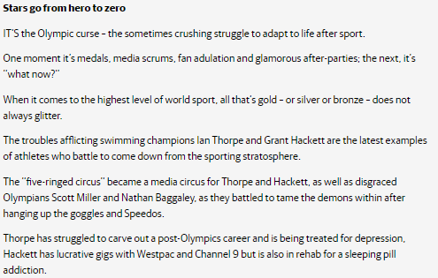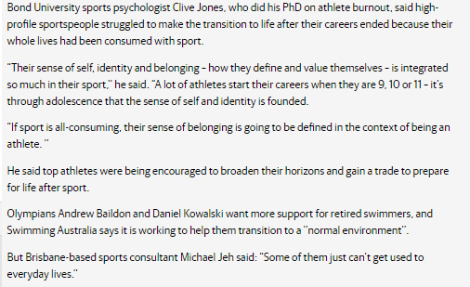

A POST-CUP TALE
By C.J. Dennis

I'ad the money in me 'and!
Fair dinkum! Right there, by the stand.
I tole me wife at breakfus' time,
Straight out: "Trivalve," I sez "is prime.
Trivalve," I sez. An', all the week,
I swear ther's no one 'eard me speak
Another 'orse's name. Why, look,
I 'ad the oil straight from a Book
On Sund'y at me cousin's place
When we was torkin' of the race.
"Trivalve," 'e sez. "'Is chance is grand."
I 'ad the money in me 'and!

Fair in me 'and I 'ad the dough!
An' then a man 'as got to go --
Wot? Tough? Look, if I 'adn't met
Jim Smith (I ain't forgave 'im yet)
'E takes an' grabs me be the coat.
"Trivalve?" 'e sez. "Ar, turn it up!
'Ow could 'e win a flamin'Cup?"
Of course, I thort 'e muster knoo.
'Im livin' near a trainer, too.

Right 'ere, like that, fair in me fist
I 'ad the notes! An' then I missed --
Missed like a mug fair on the knock
Becos 'is maggin' done me block.
"That airy goat?" 'e sez. "E's crook!"
Fair knocked me back, 'e did. An' look,
I 'ad the money in me 'and!
Fair in me paw! An', un'erstand,
Sixes at least I coulder got --
Thirty to five, an' made a pot.
Today I mighter been reel rich --
Rollin' in dough! Instid o' which,
'Ere's me - Aw! Don't it beat the band?
I 'AD THE MONEY IN ME 'AND!
Put me clean off, that's wot 'e did ...
Say, could yeh len' us 'arf a quid?

"Den"
Herald, 2 November 1927

Focus 2: Are sports people role models?

To begin the focus module, teacher will ask students to come up with a list of people who are their role models, and why. Examples might be, Arnold Swazenegger because he is a body builder, Barrack Obama for succeeding in politics despite obstacles or Jennifer Lopez because she sings well. Examples might also be local people or family members.

As a class brainstorm which sports people might be considered role models and why? Students put this information in work books.

- On the flip side, class might also offer some sports people who have been heavily criticised for their public behaviour.
- David Warner’s racial slurs, Todd Carney’s off-field antics, Tiger Wood’s affair, Mike Tyson’s ear biting, Lance Armstrong’s drug abuse.

Prezi Slideshow –  Students take notes from The Language of Information.  Once teacher has been through the presentation, teacher to discuss emotive vs objective language. A resource sheet offering examples of both, and writing samples to be completed by students.  If the class allows it, students might share some of their responses and peer review them. Students might ask the question of themselves, ‘what contributes to a highly emotive sentence?’. | H3.1, H3.2
Tone – the quality of sound of one’s voice. Tone could indicate levels of excitement, joy or boredom etc. Tone can be communicated by the words on the page, but is easier to identify in spoken texts.  Students will view youtube clip, ‘Top 10 Plays of the NRL season’ and teacher will prompt students to discuss the tone of each clip.  Students may also identify repetition and particular phrases which contribute to the emotion in the clip.  Students will work to re-write each of the clips in matter of fact (objective) language, and to narrate over the top of the clip.  At the conclusion of the task, teacher to wonder, why is it that these players, who we’ve just seen kick and run, get so much attention in our society and indeed, would be considered role models. Should they be role models or not? – if class is one sided, teacher to play devil’s advocate. | H1.4  H2.1, H2.3  H3.1, H3.2
Task:  Students will be offered the first three pages from Cathy Freeman’s autobiography, Born to Run. Students will read through the extract and pull out just the facts. No waffle, no anecdote, just fact. They are to write the bones of the text in their books.  In a second list, students will give each story from her past a heading and create a list of these.  - Why do you think Freeman has chosen to include personal stories from her past in this text?  (Teacher to use this question to discuss context when answering questions).  - What would be more entertaining to read – a text with many overlapping stories, or just the facts?  - If the audience didn’t empathise with Cathy, could she operate as a role model?  - Probably not, if we don’t have any connection with a person, we generally are disinterested in what they do, think, say, etc. | H1.1
Follow On:  When we watch the news, there is an assumption that we are watching fact, but how much of the news is objective? Class might discuss the idea that the news is moving into being a form of reality TV, or has too great a focus on entertainment value.  Homework task:  Students to watch a news program and report back on the stories which are being told. Are we simply getting fact? Or is the news contributing to the ‘cult-ification’ of sports people by providing their personal stories and context? | H2.1, H2.2
Weekly Class Debate:  Sportspeople should be role models  Students write up dot points to support both sides of the debate in their workbooks. Students to complete their notes individually before taking a side to support.  Following the debate, students will write a personal response arguing whether sport is a good marker of identity. Students will support their point of view with at least two reasons.  Teacher to model activity on board, and if necessary, brain storm some ideas with the class. | H2.1, H2.2, H2.3  H3.1, H3.2  H4.1, H4.2

Emotive vs Objective Language
Emotive language is the deliberate choice of words to elicit emotion (usually to influence).
Objective language presents ideas in such a manner that the facts are presented without making judgments on those facts.

Non-emotive version: Another person in the bar was injured by the man's glass.
Emotive version: An innocent bystander suffered facial injuries when the thug launched his glass across the bar.

Non-emotive version: The government will reduce interest rates.
Emotive version: The government will slash interest rates.

Non-emotive version: Mr Smith was attacked by Mr Jones for two minutes.
Emotive version: For what seemed a lifetime, Mr Smith was subjected to a vicious, cowardly assault by the unemployed, steroid-pumped monster.

Change the following sentences to make use of emotive language:

Mrs Smith had a baby girl.

The cricket player hit a six.

Mr Campbell was late for the party.

Change the following sentences to make use of objective language:

The proud father embraced his princess when she told him she was engaged.

The gang was quickly approaching their victims with hatred in their eyes.

The girl’s voice was quivering as she readied herself to ask about the consequences of her devious actions.

Prezi Shots – Available online
The Language of Information

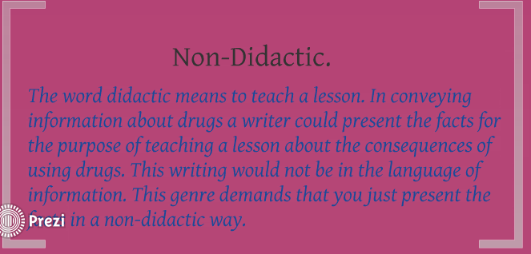
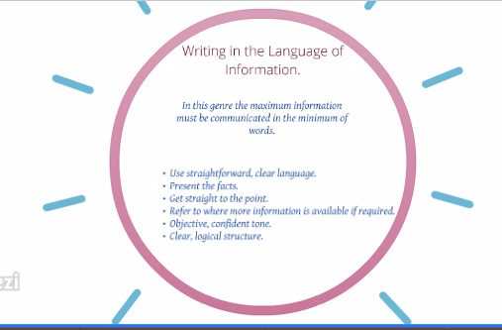

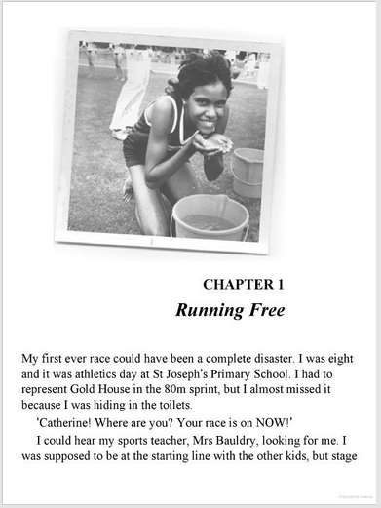
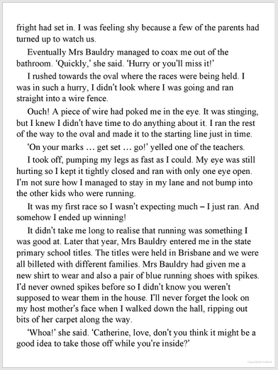
Excerpt from Cathy Freeman’s autobiography, ‘Born to run’.

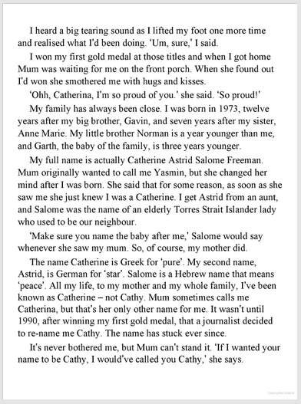

Focus 3: The Blame Game

Introductory Game:  Students will be given a character (as below) upon entering room, they will write some notes up in the voice of the character before a class discussion occurs.  Teacher to set the scene-  The biggest football match the North Coast will ever see will be played out on Saturday night. The highly anticipated match is between the Taree Turtles and the Old Bar Octopuses.  - How does your character feel about the upcoming match?  - What are your chances of victory?  - What does victory mean to you?  The match has started, and the fans are going wild on both sides. There is a strong anticipation on both sides of the field for a special performance, and of course, victory. The kick off marks the start of a high intensity half, in which both sides are getting a little bit physical. Yellow cards are popping up everywhere, and players from both sides have been subbed out with injury. As the half time whistle blows, the scores are locked at 0-0, despite numerous chances from both sides to get on the score board.  - If you’re a fan, how do you feel about your team right now?  - If you’re a fan, how do you feel about your opposition?  - If you’re a coach, what would you say to your team?  - If you’re a captain, what would you say right now?  - If you’re the star player, ask yourself the question: why are you not winning right now?  Heading into the second half, the crowd resumes their seats and the teams run back out on to the pitch. Both sides seem to be a fired up, and the half sets off with a quick pass and the intensity of the match resumes. Both sides steal momentum from the other, and opportunities are missed. You can see the players looking increasingly frustrated – shoot, save, shoot, miss, tackle, yellow card, corner kick, miss. Then, the striker for the Old Bar Octopuses centres the ball in to the box – the goalie runs for the ball, and bumps in to the centre striker in the air. Both fall to the ground, the ball secure in the arms of the goalie… but the whistle blows, and it’s a penalty kick in the box – the Octopuses cheer while the ref feels the vicious sting of not just the turtles players, but the entire crowd of fans. It’s too late to reconsider the call, it’s been made and the ball is placed and the free kick taken… and, and, and it’s a goal, the Octopuses win as the final hooter brings the game to a close.  - Write down how you feel about the result.  - What went wrong? Who’s to blame?  - How do you think this match would be reported in the news?  (Teacher to direct conversation around the idea that we would celebrate with the victors, and the losers would tend to be overlooked – or displaying poor sportsmanship by complaining about the result or the referee etc.) | H2.2  H3.1
Features of a magazine  Students are given the magazine article: ‘Cahil: we can make mistakes now, not in the Asian cup’.  With teacher’s assistance, students to annotate their article:  - Image to support what/who the article is about.  Prior to reading the article, can students ‘read’ the image to predict what the article will be about.  - Colour can grab the attention of the reader  - Heading in bold, large font, stands out – provides indication about what the article is about.  - Sub-heading builds information already offered by article, and usually provides context for the article. Usually in bold.  - Quotations make the article more interesting by providing the thoughts of others.  - Description about what has happened. Neutral language should be used, but often articles contain bias.  - Final paragraph seeks to answer the question, ‘what next?’. | H1.1
Students are given the sports section from the newspaper, which they will in turn analyse. They will need to pick one article, and for that article:  - Write down the heading  - How is the heading relevant to the article?  - Is the heading direct or does it invite your curiosity?  - Big words or short words?  - Do the headings make use of alliteration / rhyme / slang / rhetorical questions?  - Emotive language?  - Where / What / When / Who  - Does your article include quotations? Are they effective in communicating a point?  - Does the article contain bias? Either positive or negative –  - Long or short paragraphs? Why do you think the article does this?  - How much detail does your article go into?  - Does the article conclude by looking to the future, or reinforcing a suggestion from the article? Is the ending effective? | H1.1, H1.2, H1.3
Writing a feature article:  Harry Potter and the Philosopher's Stone: Clip - Harry's First Quidditch Match (Youtube, 1 minute 45 seconds).  Students will watch the clip through once, and discuss what has occurred. After viewing the clip, teacher will ask the class what an article on the game might include, some suggestions might be:  - Headline  - Subheading  - Contextualising the event – where / what / who / when  - Description of the action  - The reaction of the crowd (including quotations)  - What’s going to happen next match?  If students are thinking outside of the clip, they may choose to include made up quotations which fit into their text.  - Critical Consideration  In the film, the audience is positioned to cheer for Harry and support him in all his endeavours, so naturally we enjoy his success and the success of his house team. Does sportsmanship appear to be a consideration in this text? | H1.4  H2.3  H3.1, H3.2
Student’s view teacher powerpoint, Tennis Tantrums, a compilation of youtube clips showing tennis players having moments. Having viewed the clips students will draw up advice/speech which they would offer to younger peers about being a good sport.  Structure of writing  Introduction – why is sportsmanship important?  Paragraph – example of what good sportsmanship is. How does being a good sport allow you to be represented? How does it make others see you?  Paragraph – example of what bad sportsmanship is. How does it feel when others are bad sports to you? How are bad sports remembered?  Recommendation – rhetorical question challenging students to be good sports. Use of ‘imagine’ statements might help students position their audience in a sporting role.  Think of the examples that you offer – personal examples / friends / famous sporting people / fiction (film or novel). Try avoiding using the same kind of example twice.  Teacher to model one of the paragraphs and work with students to complete their individual pieces. Students will be able to read their motivation.  To assist in the task, teacher might choose to play some coaches motivational speeches, as the persuasive techniques may overlap.  ‘Ducks fly together’ - Youtube (Mighty Ducks II) | H1.4  H2.3  H3.1, H3.2
Class Debate:  - Context – sports people play sport as a career, and they put 1000s of hours each year in to practising their game. Their profile, earnings and reputation are at stake every time they win or lose, and when referees make the wrong decision, it can lead to significant financial, emotional or career disadvantage.  - Topic: Professional athletes can be justified showing bad sportsmanship.  Students write up dot points to support both sides of the debate in their workbooks. Students to complete their notes individually before taking a side to support.  Following the debate, students will write a personal response arguing whether sport is a good marker of identity. Students will support their point of view with at least two reasons. | H2.1, H2.2, H2.3  H3.1, H3.2  H4.1, H4.2
Optional Tangent:
- Sportsmen can make millions of dollars a year for throwing a ball, but they may be uneducated and have no real ambition in life. Is this fair? Does the paying of athletes such large sums, devalue the work of the rest of our community? Does it mean being a policeman, plumber or pig farmer isn’t as ‘valuable’ to society as a sportsperson?

Blame Game Characters
Students to be allocated the roles as below, if any additional roles are needed for class, utilise additional fans or players. Be sure to have balanced sides in the room. For the success of the game, you should take your role seriously and get in to the greatest grudge match the city has ever hosted!

Captain of Octoupuses | Captain of Turtles
Coach of Octopuses | Coach of Turtles
President of Octopus Fan Club | President of Turtles’ Fan Club
Passionate Octopus Fan | Passionate Turtles Fan
Star Player – Octopus | Star Player – Turtles
Injured Player – Octopus | Injured Player – Turtles
Trainer / Assistant Coach – Octopus | Trainer / Assistant Coach – Turtles
Club President – Octopus | Club President – Turtles

Features of a magazine article.
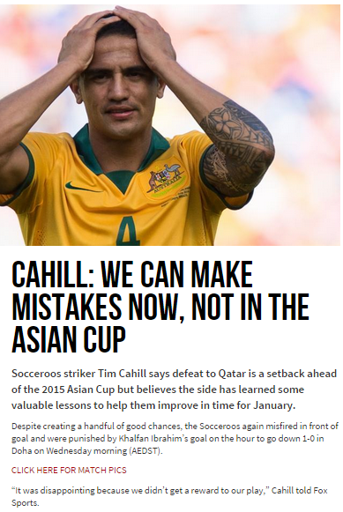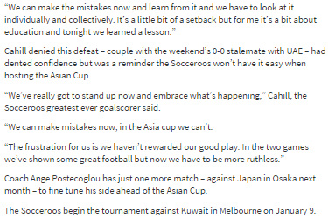

This Unsporting Life
Dominc Knight

When I was but a young lad of 16, I was visiting another school for a tennis match when some friends called to me from a cricket pitch. It was the mighty Fourth XI (out of four) and, given our school’s traditional indifference to sport, they were down a player who hadn’t bothered to turn up. Would I be willing to fill in as last drop?

Would I ever. As an Australian male, I’d like to think I know a thing or two about cricket. I’d even played competitively in year 7 or year 8 (well, if you count losing every single match as “competitive”). And I once scored 12, one of the highest scores all season. So I thought it would be child’s play to put on a quick-fire, Viv Richards-style half-century so my admiring teammates could carry me off the field, triumphantly brandishing a stump.

I donned (in the sense of “putting on”, not “reminiscent of Don Bradman”) some pads but opted – hygienically – not to use the “box”, which had already been down the undies of most of my sweaty teammates. I jauntily strolled out to the middle, bat propped rakishly over my shoulder, communicating to the bowler that I was made of better stuff than the amateurs he’d been facing earlier. I took guard. The bowler began his run-up. And propelled his first medium-slow delivery right into my crotch.

Honestly, the pain was excruciating … but even more agonising for an adolescent whose manhood had just been metaphorically (and literally) crushed were the taunts. “Balls before wicket!” said one wag. My pride also retired hurt that day. And I haven’t played cricket with a real ball since. Because, despite my enduring love of it, despite my fantasies whenever I take to the field that somehow things will be different this time, I am crap at sport.

I don’t “throw like a girl” or take wild air swings and miss completely. I’m not like a scene from Revenge Of The Nerds (well, not in that respect anyway). I just mean that every single time I play sport, whether it’s soccer, table tennis or tenpin bowling, I’m invariably the most mediocre. That’s not how Aussie blokes are supposed to be. My passport is meant to give me mystical powers of eye-to-hand co-ordination as well as bucket-loads of Aussie spirit. The Australian way is to fight above our weight and bring back the glory. It’s Steve Waugh scoring that century in an afternoon at the SCG. It’s Lleyton Hewitt chasing down every damned ball on his way to a Wimbledon title (as opposed to chasing Bec Cartwright). It’s our hero Socceroos, except in the years 1975 to 2005. But the only champion sportsman I have any chance of emulating is Steven Bradbury. And I’d need a much greater number of people to collapse in a heap ahead of me before I took home any medals.

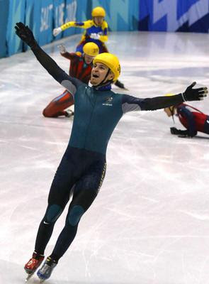
We’re not a country where you get points for trying. When Ricky Ponting’s team surrendered the Ashes, we didn’t congratulate them on getting close. We were devastated. And that’s my problem. I play soccer with a bunch of mates in the park on weekends – unfit, lazy blokes who, for the most part, ought to be just as bad as me. But for some reason, they effortlessly outclass me. So I make fun of myself before others can, all the while sobbing on the inside like a baby. And even though all of us could pretty much serve as a second Nerds FC team, the whole thing’s become ultra-competitive. I’ve been shouted at for not tackling hard enough and the girls who used to play with us for fun are long gone, tired of balls being kicked in their faces … because Australian men don’t do “social” sport. Even for toddlers at kindy, it’s war.

It’s surprising we aren’t more tolerant of sporting failures when the most revered example of Australian manhood is the Gallipoli landing. (And believe me, I get hammered on the beach just playing Frisbee.) English football fans can obsess over tiny, unsuccessful regional teams but the Sydney Swans only get crowds when they’re winning. While in Melbourne, an Essendon v Carlton match takes on the seriousness of a blood feud – even when both are at the bottom of the ladder.

Where does that leave those like me, whose genes simply aren’t cut out for it? Jealous and resentful, frankly. Since we’re already confined to the shallow end of sport’s gene pool, the least you could do is not sledge us. We’re already painfully aware that we’re rubbish and your mum could do a better job. Believe me.

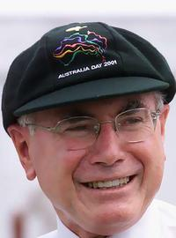
Jocks ought to be careful how much they pick on my kind, though. John Howard loves cricket more than he loves the Queen – and that’s saying something. However, he’s not only the bloke who hands out that all-important Australian Institute of Sport funding – he gets to open the Olympics and pick the Prime Minister’s XI. And that truly is the revenge of the nerds.

Questions:
1. How does the first person point of view of this text establish connections with the responder?

2. Comment on the use of colloquial language in this text. How does it add to the appeal of the text?

3. What sporting jargon does the author of This Unsporting Life use?

4. According to this article, what attributes do Australians value?

5. What is the author’s opinion of his sporting abilities? How does he justify his lack of sporting prowess?

Focus 4: An equal playing field?
Class brainstorm:
What is gender inequality?
Where does it occur? What does it look like?

Students participate in discussion, then write down information in to their books.

Teacher may need to set up a second mind map, specifically, gender inequality in sport. This brainstorm does not need to focus on issues of discrimination, but may also note some physiological differences.

Give the female athletes a level playing field on funding, Justin Quill, September 22, 2013, Herald Sun.  - What kind of gender discrimination does the heading for this article imply?  - Complete the following table, using the main article, and the blog points by Felicty Harley  Issue Evidence  Women in sport underpaid  Women in sport not given equal opportunity to compete  Female athletes are not able to be marketed  Women’s sport is not given equal media treatment. | H1.1, H1.2, H1.3
What kind of roles did women take on in WWII? Teacher to draw out prior knowledge of students  - Women took on many roles on the home front left vacant by men who went to fight. The factory and farm, formerly men’s domain, needed women to complete duties left behind.  - Nursing  - In Russia, women even became fighter pilots – the witches of Stalingrad.  - Women had opportunities to be more masculine, and ideas of gender in society changed, however, as was the case following WWI, patriarchal ideas kicked in again post conflict.  - Sport was one area (as entertain) which called on women during war, in America, this led to the formation of a women’s baseball league in 1943.  Define: Patriarchy  - Society which privileges male power over females.  Define: Feminism  - To establish equal political, economic and social rights for women. It is not about dominating men.  Students watch the film, A League of Their Own, 1992, directed by Penny Marshall. Teacher will need to allow 2 periods (120 minutes) to view the film in its entirety (text has a PG rating).  At the conclusion of the film, teacher to question class –  - How did the film deal with the idea of gender in sport?  - Did the film promote ideas of feminism?  - Did the film promote ideas of patriarchy?  This may lead in to a discussion around the idea that women were allowed to play baseball and be masculine, but had to at all times remain feminine.  Further discussion: How does the film reflect the role of sports (its importance) and effect on a community/country? (Bring this in to an Australian space). | H1.2
Students are given a copy of, ‘A Guide for All American Girls’, which was distributed to all players in the women’s baseball league. Students to answer the following questions:  • What was the ideal for the All-American girl baseball player?  • What did the league managers want from their players, in  terms of traditional feminine qualities, appearance or  behaviour?  • Why did the league give this guide to its players?  • Why does the Guide emphasize beauty and make-up?  • Do any parts of this guide sound strange to us today? Why?  Why did the league, and indeed, society (as informed through the media) need women to be ladies (despite playing a ‘men’s game’)? | H1.1, H1.2  H2.1, H2.2
Weekly Class Debate:  Women deserve equal pay for equal play.  Students write up dot points to support both sides of the debate in their workbooks. Students to complete their notes individually before taking a side to support.  Following the debate, students will write a personal response arguing whether sport is a good marker of identity. Students will support their point of view with at least two reasons. | H2.1, H2.2, H2.3  H3.1, H3.2  H4.1, H4.2

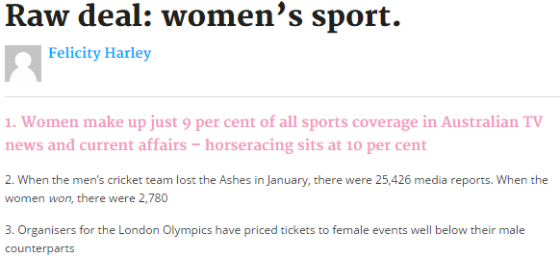
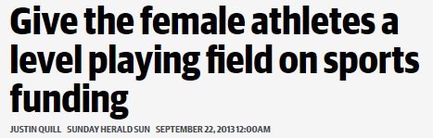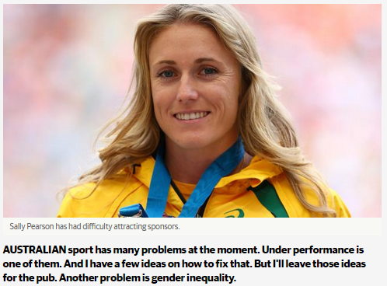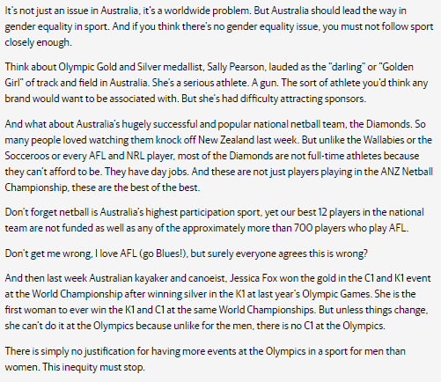

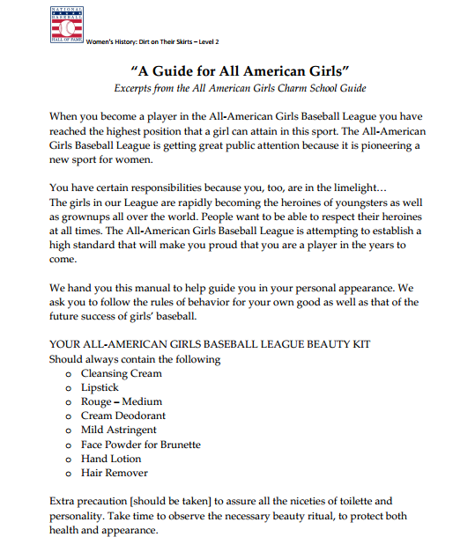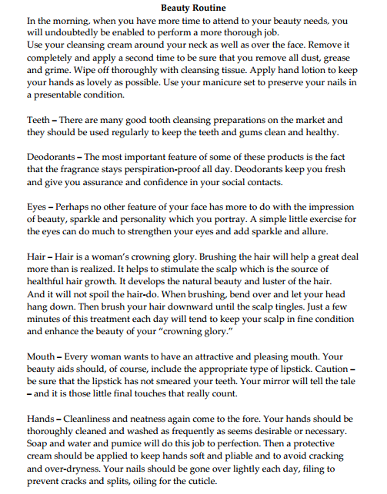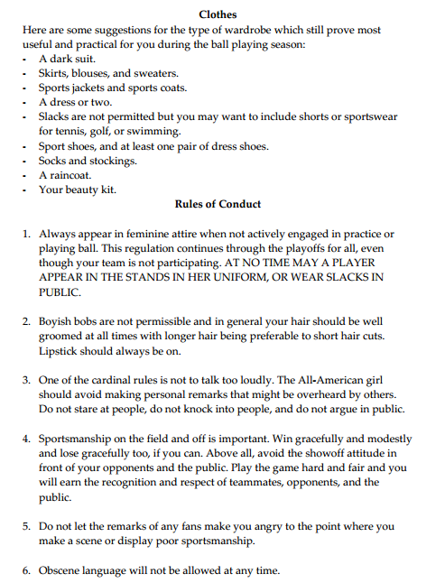

Focus 5: Ethics and Cheating in Sport
Ask students to share a story from their past, when they have cheated in a game, or observed someone else cheating.
- This may be they took extra money in Monopoly, or didn’t accept they were out in handball etc.

Students to write down what happened in objective language, and then answer the following questions.
- Explain why the incident was wrong.
- How did the incident make you feel if you someone cheated against you, or how did the incident make you feel if you were the cheater.
- What were the consequences for your actions?

Ethics:
Ethics refers to well-founded standards of right and wrong that prescribe what humans ought to do, usually in terms of rights, obligations, benefits to society, fairness, or specific virtues.

Referring to the above definition, students might identify that cheating in sport would be unethical as it becomes an issue of ‘fairness’.

Students view the clip at Behind the News – Sports Cheating – 19/02/2003

Students are questioned about what or who they believe a hero is – with an emphasis on the qualities and characteristics of a sporting hero.  Prior to students receiving their text, ‘Hero’, by Mick Gower – teacher to further prompt, what kind of image would an older, sporting hero portray?  Students read the poem, and answer the questions on the sheet in their work booklets. Once students have completed this task, a further conversation might take place:  The man’s greatest achievement happened when he was 23, he is presumably now in his 80s or older. How has taking drugs and winning that gold, and the hero status it thrust on him, bettered or ruined his life? discussion may revolve around the idea that he lived his entire life looking back at one moment; was the rest of his life wasted in memory? | H1.1, H1.2, H1.3  H2.1, H2.2
Australian Drug Foundation  Fact Sheet – Performance and Image Enhancing Drugs (PIEDS)  Students review the fact sheet, and answer the following questions:  - What does the acronym PIED stand for?  - What are some examples of PIEDs?  - Why do athletes use PIEDs as part of their training?  - Give specific advantages  - PIEDs have significant side effects, of the list of harms on the fact sheet, which do you think are the two most serious and argue why. | H1.2  H2.1
The class will read Mike Agostini’s editorial, Drugs in Sport – Just get over it, Sydney Morning Herald, 2006.  Having read the text, the class will identify Agostini’s argument – that we should look the other way when it comes to drugs and appreciate the sport for what it is, corrupt, but entertaining. That when there is so much money at stake, of course athletes will do what is necessary to get the cash in their own pockets, particularly when the playing field is uneven anyways.  Students are asked whether they agree or disagree, and their reasons for doing so. They might make dot points of their reasons in their books.  Students will be given a model letter to the editor to review, the teacher will guide students through the letter and the annotations. Students will use this as a guide for writing their own letter to the editor, in response to Agostini’s editorial. Students will be informed that this will be a drafted exercise and teacher will go through some features of persuasive writing.  - Use facts and opinion  - Emotive language  - Imperative verbs  - Direct appeal to audience  - Connectives, firstly, therefore, however, in conclusion, additionally etc.  - Quote ‘expert’ sources  Prior to writing their text, students will be given a marking criteria, and come to an understanding of what the task demands. At the conclusion of the task, students will work with another student to peer review their work and give them a mark out of 15. | H1.1, H1.2, H1.3, H1.4  H2.1, H2.2, H2.3  H3.1, H3.2  H4.1
Optional Activity:  If time allows, students will be given the opportunity to come up with a rap about drugs in sport. Students might have a rap battle with what they’ve come up with – with possibility of arguing both sides of the case.  ‘Yo yo, when it comes to drugs just say no bro’.  ‘run faster, don’t wanna be last-er’. | H1.4
Assessment Task:  Students are given their assessment task, Drugs in Sport, which they will deliver a visual/oral presentation on. Students will go through the expectations of the task with their teacher, and be allocated time in class to research and prepare their presentation. | H1.4  H2.2  H3.1, H3.2  H4.1, H4.2
Weekly Class Debate:  Drugs contribute positively to the spectacle of sport  Students have been writing in the positive in previous debates, this topic will allow them more room to argue in the negative.  Students write up dot points to support both sides of the debate in their workbooks. Students to complete their notes individually before taking a side to support.  As students have completed a similar activity in their editorial task, they will not need to write up their personal response. | H2.1, H2.2, H2.3  H3.1, H3.2  H4.1, H4.2

“Hero”, by Mick Gower

‘
Of course I took drugs. Look, son,
there’s no fair play, no gentlemen,
no amateurs, just winning.
How old are you? Fifteen? Well,
you should know that
no-one runs for fun - well, not beyond
the schoolboy stuff - eleven or twelve years old.
I’d been pro for years; my job - to get that gold.

Mind you, we English are an odd lot:
like to believe we love the slob that fails,
the gentlemanly third;
so any gap-toothed yob who gets the glory
also gets some gentlemanly trait: helps cripples get across
the street, nice to small animals. You know the kind of thing,
it helps the public feel it’s
all legit: the sportsmanship is real and that it’s all clean fun -
the strongest, bravest, fittest,
best man won.

Yeah, steroids... What do you think?...
Oh, don’t be wet -
My coach, of course, he used to get them
through this vet... The side effects? Wee, not so bad
as these things go - for eighteen months or so
I didn’t have much use for girls.
But, then I was training
for the big one - got to keep the body pure,
not waste an ounce of effort.’

He gives a great guffaw.
A chain of spittle
rattles down the front of
his pyjama jacket.
He wipes his mouth;
his eyes don’t laugh at all.

‘...Do it again? Of course I would -
I’d cheat, I’d box, I’d spike, I’d pay the devil’s price
to be that good again
for just one day. You see, at twenty-three
I peaked - got all I ever wanted:
all anyone would ever want from me.
After the race, this interviewer told me
fifty million people’s hopes and dreams had been
fulfilled. Gold!
How many ever get that chance? I did.
Of course not.

Damn, the bell. You’d better go, they’re pretty strict.
Yeah, leave the flowers there on the top,
The nurse’ll get some water and a vase.’

1. What do you think is the relationship between the man and the boy in the hospital? What is the boy’s attitude towards the man?
2. What techniques does the poem use to mirror the man’s style of speaking?
3. The poem is a monologue in that we only hear the man speaking. What do you think the boy is saying? Write down his half of the conversation.
4. What do you think of the man’s attitude? If you had been in his position, with his talent, what choices would you have made?
5. What line suggests that the man regrets his actions?
6. Who, or what, does the poem suggest is to blame for the pressuring the man to take performance enhancing drugs?

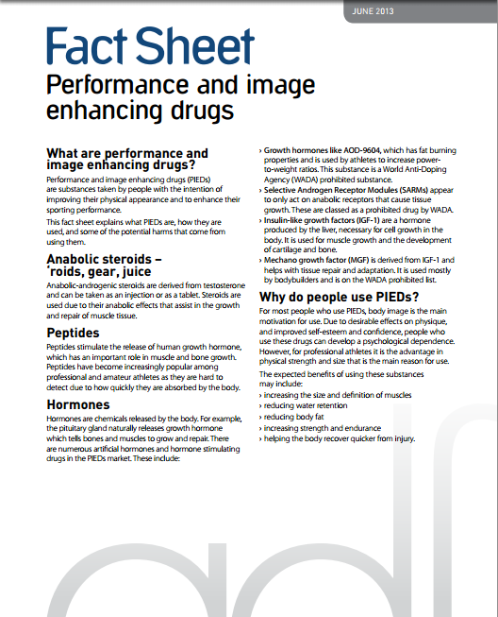

Mike Agostini
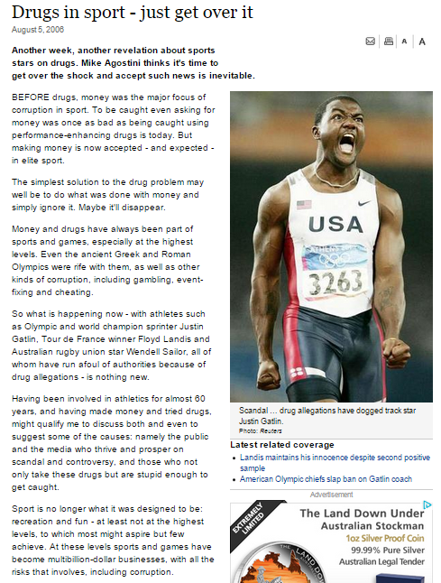

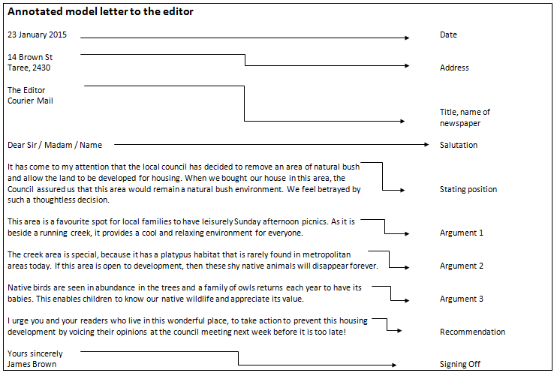

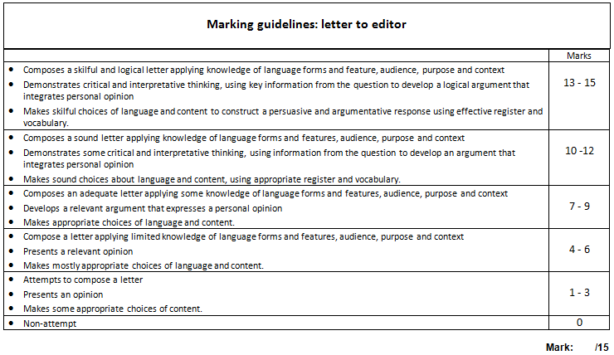

Assessment Task – Drugs in Sport

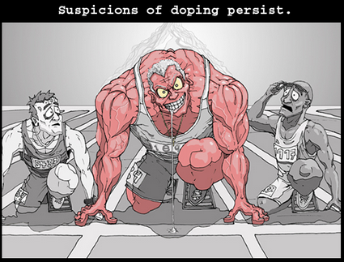
Throughout the 20th and into the 21st centuries, drug taking in sport has been a major issue as athletes have attempted to gain an unfair advantage over their competitors. Some have been motivated by greed, others the lure of success and fame. Whatever their reasons for cheating may have been, reputations have been ruined and sport has been brought in to disrepute. Your task will be to investigate an incident of cheating in sport and to report on it to the class through an oral presentation accompanied by a visual stimulus (prezi / powerpoint / posters etc.)

The following questions are a guide which will help you in your investigation:
- Context – who / where / why / what / how
- Did your athlete have success on drugs?
-How was this success represented in the media?
- What happened when your athlete was found to be a drug cheat?
-How was this represented in the media?
- What comments did your athlete make about their cheating?
- What did others associated with their sport comment about their cheating?
- What happened to your athlete post scandal? Where are they now?

Outcomes:

H1.4, H2.2, H3.1, H3.2, H4.1, H4.2

Some Key Questions to Consider:
What kind of visual presentation will I feel most comfortable presenting with? | What kind of sources will best inform me about how athletes were represented in the media?
What kind of voice will I need when delivering my oral presentation? | How much information should go on one slide? Should I write out notes on a separate sheet so I don’t forget what to say?

Marking Criteria – Drugs in Sport Oral Presentation.

13 – 15 | - Clear oral presentation, student was familiar with their content and delivered it with confidence. An appropriate and consistent tone contributed to a strong presentation.  - Presentation supported by strong vocabulary choices, and use of jargon and slang where necessary to enhance meaning.  - Content in the presentation was well researched, and student has cited where they got their information from.  - Information on slides was succinct and was a key summary of what student was saying.  - Content has been put into student’s own words, unless specific quotations used and referenced.  - Student uses slides as a prompt for discussion, rather than their entire presentation.
10 – 12 | - Student delivered a strong oral presentation, and was confident in what they were saying. Appropriate and consistent tone was adopted throughout.  - Presentation supported by clear vocabulary choices.  - Content in the presentation demonstrated sound research, and included source information.  - Slides were easy to read, and not overwhelming.  - Most of information has been put in to student’s own words.  - Student was able to talk without a heavy reliance on their slides.
7- 9 | - Student delivered a sound oral presentation, with a good attempt to maintain an appropriate and consistent tone.  - Good use of vocabulary to communicate ideas in the presentation.  - Student relied heavily on their slides for what to say.  - Content in presentation was accurate, and suited the requirements of the task. Some references may have been included.  - Student has attempted to put information in to their own words.  - Student had a lot of information on their slides, and they were at times too crowded.
4-6 | - Student delivered a satisfactory oral presentation, although lacked familiarity with content.  - Student had limited appreciation of the role of tone and vocabulary in presentation.  - Student just read from their slides.  - Presentation showed limited research skills.  - Poor attempt to put information in to student’s own words.  - Limited information in presentation, or too much information which was irrelevant to the task.
1-3 | - Student made some attempt to discuss parts of their presentation with limited understanding of appropriate tone for the task.  - Poor vocabulary choices, or vocabulary unsuited to the task.  - A limited visual presentation accompanied the oral presentation. This may have been incomplete or too short.  - Student has copied too much information without referencing the source.
0 | - Non-attempt of task  - Student submitted task beyond the due date.

Focus 6: When Things Go Wrong
Often in sport, things happen which are outside anyone’s control. They’re called accidents,

Class shares stories about times that they have had sporting injuries, or the injuries of others.

…but sometimes these ‘accidents’ have extreme consequences, including death.

“Who killed Davey Moore?” by Bob Dylan  This song considers the issue of responsibility and accountability in professional sport. It takes the perspectives of the referee, the crowd, the manager, the gambling man, the boxing writer and the opponent.  Dylan wrote this song in 1963 following the death of Davey Moore in a professional bout against Sugar Ramos on March 21, 1963. The song follows the structure of the popular children’s rhyme ‘Who Killed Cock Robin?” In each verse, a different interested party gives his reasons why he is free from culpability. However, the song leaves the listener with the distinct impression that all share the blame, no matter how hard they deny it. The final line of the song, It was God’s will, is the actual words used by Geraldine Moore when she learned of her husband’s death.  Class will watch a clip of Dylan singing his song, and read the accompanying lyrics. At the end of the song, students will look at the lyrics and attempt to justify who is the most accountable person leading to the death of Moore. The teacher may challenge the class to find agreement on one person. | H1.1, H1.2, H1.3
Teacher will conclude the activity by suggesting that in sport, no one is directly responsible for the death of a sports person, but indeed, everyone shares some degree of responsibility.  Teacher will show a compilation highlighting various accidents across various sports.  - Arton Senna (Motor Racing)  - Philip Hughes (Cricket)  - Amy Gillett (Cycling)  - Caitlin Forrest (Jockey)  - Malik Joyeux (Surfing)  Teacher will note that these athletes all died while competing, as have thousands of other athletes who have ran in to goal posts, had cardiac arrests on the field, been hit with baseball bats and pushed their bodies beyond the limit during training and marathons.  Teacher may wonder, was their death worth it? And this will lead in to the final debate of the unit,  Should professional sports exist?  Students prompted to think of the scope of the unit in their responses:  - Sport robbing athletes of their identity  - Exploitation of athletes for national interest  - Robbing athletes of a private life  - Expectation that athletes will be role models  - Limited opportunities post sport career  - Promotes gambling in our society  - Promotes cheating and unethical behaviour as necessary or normal.  - Pressure to improve oneself (unhealthy self-image?)  - Harm to body through drug addiction  - Death  - Aggression (passion?) in cheering for team – promoting hate and nationalism.  - Poor sportsmanship supported by all  - Devaluing of non-sporting professions $$  Students write up dot points to support both sides of the debate in their workbooks. Students to complete their notes individually before taking a side to support.  Following the debate, students will write a personal response arguing whether sport is a good marker of identity. Students will support their point of view with at least two reasons. | H2.1, H2.2, H2.3  H3.1, H3.2  H4.1, H4.2

Who killed Davey Moore? – Bob Dyaln.

Who killed Davey Moore?
Why an’ what’s the reason for?

‘Not I,’ says the referee,
‘Don’t point your finger at me.
I could have stopped it in the eighth
And maybe kept him from his fate,
But the crowd would’ve booed, I’m sure,
At not getting their money’s worth.
It’s too bad he had to go,
But there was pressure on me too, you now.
It wasn’t me that made him fall,
No, you can’t blame me at all.’

‘Not us,’ says the angry crowd,
Whose screams filled the arena loud.
‘It’s too bad he died that night
But we just like to see a fight.
We didn’t mean for him to meet his death.
We just meant to see some sweat.
There ain’t nothing wrong in that.
It wasn’t us that made him fall,
No, you can’t blame us at all.’

‘Not me,’ says his manager,
Puffing his big cigar,
‘It’s hard to say, it’s hard to tell,
I always thought that he was well.
It’s too bad for his wife an’ kids he’s dead,
But if he was sick, he should’ve said.
It wasn’t me that made him fall,
No, you can’t blame me at all.’

‘Not me,’ says the gambling man,
With his ticket stubs still in his hand.
‘It wasn’t me that knocked him down -
My hands never touched him none.
I didn’t commit no ugly sin;
Anyway I put my money on him to win.
It wasn’t me that made him fall,
No, you can’t blame me at all.’

‘Not me,’ says the bowing writer,
Pounding print on his old typewriter,
Sayin’ ‘Boxing ain’t to blame-
There’s just as much danger in a football game.’
Sayin’ ‘Fist fighting is here to stay,
It’s just the old American way.
It wasn’t me that made him fall.
No, you can’t blame me at all.’

‘Not me,’ says the man whose fists
Laid him low in a cloud of mist,
Who came here from Cuba’s door
Where boxing ain’t allowed no more.
‘I hit him, yes, it’s true,
But that’s what I’m paid to do.
Don’t say “murder”, don’t say “kill”,
It was destiny, it was God’s will.’

Additional Activities or Homework
Greatest Athletes in Sport
Students will come up with a list of who they believe the five greatest athletes in history are, and why. As students each compile their list, and argue their choices, ask the class to come up with a single list.

Sports News Program
Give students the chance to script and film their own sports program. They will need to design their characters, write their stories and film their end product. In completing the task students will come to an understanding of what might occur to make sport into entertainment.

Students might model their show on The Footy Show, a quiz show or news bulletin.

Promotional Material
Students may develop promotional material for:
- Promoting fair play in sport (sportsmanship, drug use etc)
- Their own fictional team – this could occur as an extension of students creating their own ‘fantasy team’.

To practise critiquing film, students may choose to view films at home and analyse how the film portrays sport.
- Sandlot Kids
- Field of Dreams
- Chariots of Fire etc.

Sports Journal
Students who participate in organised weekend sport, or individual sporting events may choose to keep a journal or log of their achievements and game progress.

Alternatively, students could keep a log of their training, recording running times etc.

Novel/Theatre Assignment
Students should choose a novel to read across the term, of course the novel could be in any genre, however, students may choose to read:
- Deadly Una
- The Story of Tom Brennan
- The Big Men Fly

Obscure Sport
Research an obscure sport, and present the sport, including its origins, rules and championships to the class through an oral presentation.

