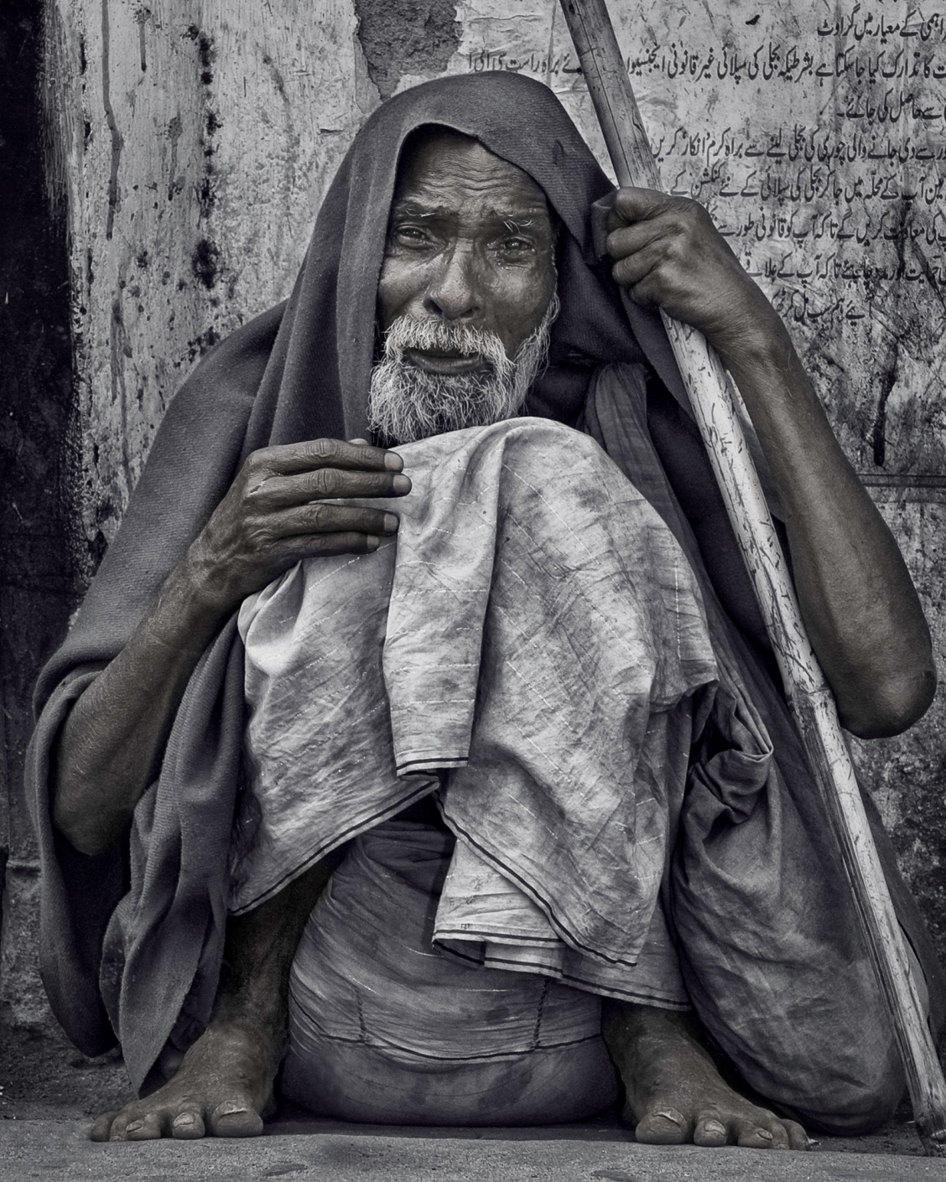

African Beggar
Raymond Tong

African Beggar
Raymond Tong

Sprawled in the dust outside the Syrian store,
a target for small children, dogs and flies,
a heap of verminous rags and matted hair,
he watches us with cunning, reptile eyes,
his noseless, smallpoxed face creased in a sneer.

Sometimes he shows his yellow stumps of teeth
and whines for alms, perceiving that we bear
the curse of pity; a grotesque mask of death,
with hands like claws about his begging-bowl.

But often he is lying all alone
within the shadow of a crumbling wall,
lost in the trackless jungle of his pain,
clutching the pitiless red earth in vain
and whimpering like a stricken animal.

Questions for African Beggar
1. Explain in your own words what you think the poem is about.
2. What evidence is there in stanza 1 that establishes the man’s destitution?
3. What does the metaphor “target” suggest?
4. What is the animal imagery in stanza 1? What does it suggest about the beggar?
5. Which line in stanza 1 indicates that disease is rampant in African slums?
6. What is suggested by the word “sneer”?
7. How is onomatopoeia used in stanza 2? What is the effect?
8. What is the metaphor in stanza 2 that creates a sense of repulsion and pity for the beggar?
9. Identify a simile in stanza 2 and explain what it means.
10. What do you think is meant by the phrase, ‘curse of pity’?
10. What evidence is there in stanza 3 that indicates he is neglected and ignored by society?
11. Identify a simile in stanza 3 and explains what it means.
12. What technique is evident in the last line of the poem? What imagery does it create for the reader?
13. How is sympathy for the beggar created through the poem?
Empathy Questions
1. Have you ever seen a beggar or a homeless person in real life? Explain the situation. What did was your response to this person?
2. How are homeless people perceived in our society?
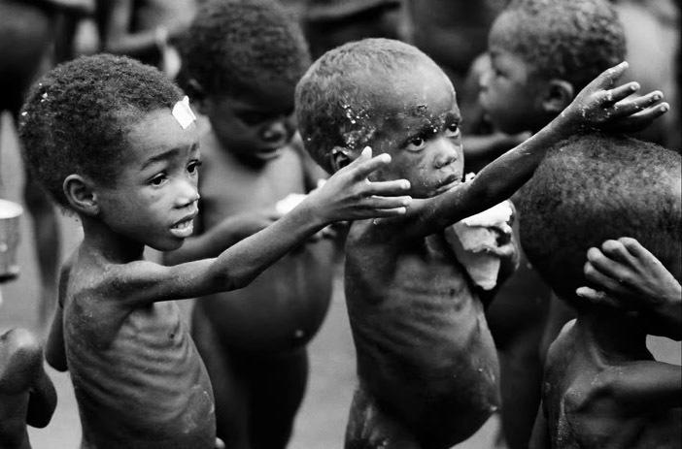
3. What do you think the African beggar thinks about the world, and his place in it?
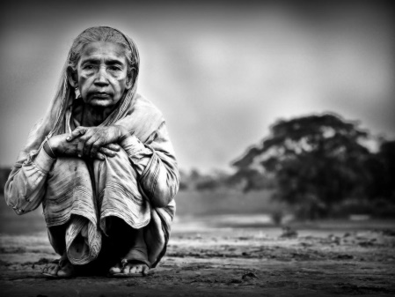

Raymond Tong

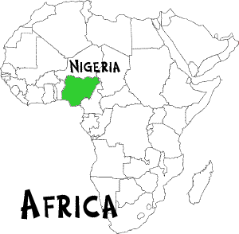
Tong travelled to Africa in 1949 to serve as an Education Officer with The British Council. He worked in Nigeria from 1949 to 1958, and Uganda from 1958 to 1961. After leaving Africa he worked in a more senior position with the Council in India, the Middle East and South America.
"Tong is a product of the optimistic, post-World War II generation, who believed that they could fashion a better, but more uniform world, one in which poverty was humanely banished and the former colonies set free as modern (namely Western) democracies" (Aiden Rankin).
Tong cared deeply for the people of Africa, and he felt Britain's attempts to enforce "progress" ultimately led to the decline of the continent's spirit. This occurred with the installation of new dictatorships and the spruiking of political sentiment (mostly emerging from England) about aiding the poor which was not matched with action.
Tong has written educational texts, a Nigerian travel book and nine volumes of poetry. In 1978 he published Crossing the Border which included his African poems. The book highlighted the change in his political thinking as he left Britain after the war with traditional ideas and a conservative approach to politics. After his time abroad, however, he became increasingly outspoken in his demands for social justice, not just in Africa, but England too.
The British Council (originally called the ‘British Committee for Relations with Other Countries’) was founded in 1934. Our first overseas offices opened in 1938.
This was a time when the status of the UK was changing dramatically. We were established to build new international relationships, based on mutual understanding rather than political or military dominance.
In 1940 we were granted a Royal Charter. Our mission in the Royal Charter was stated as: “promoting a wider knowledge of [the United Kingdom] and the English language abroad and developing closer cultural relations between [the UK] and other countries”.
http://www.britishcouncil.org/organisation/histor

Context: The environment in which a text is created –
Personal Context, Historical Context, Social Context, Political Context, etc.
Context is important because it helps the reader to understand a text.

After reading the following notes on the poem’s composer, Raymond Tong, answer the following questions:
- Why do you think Tong went to Africa in 1948?
- As an educated, middle-class Briton, working for The British Council, do you think Tong’s experiences in Africa would have matched his expectations of the continent?
- How do you think Tong feels about the beggar?
Use evidence to back up your answer.
- How do you think Tong feels about Nigeria?
Use evidence to back up your answer.
- Why do you think Tong wrote this poem?
Class Discussion:
Cultural context is also important to understand with this poem, as we are offered Tong’s perspective – that is, an outsider looking in. Do you think the local people would have been so struck by this eponymous figure?

